October
2020
Cape Mudge Youth Program
Back to group, with extra safety precautions  We are excited to start back slowly into our youth program with smaller groups. We are taking extra sanitization steps and organizing the program to meet We Wai Kai COVID-19 guidelines. We have restructured the group to help maintain social distancing with no more than 4 youth at a time. Please inform youth of proper social distancing and hand washing/ sanitizing before first day back to group. Masks are available at the youth group if needed. Safety is a priority for us all. Looking forward to having some fun activities this month! | 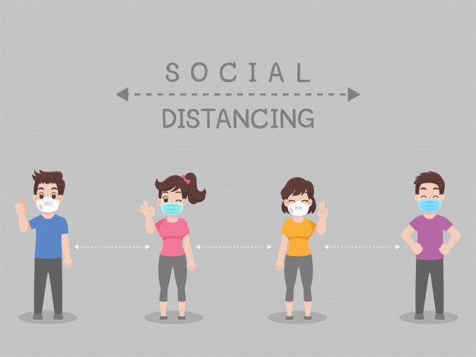
Tuesday |  | Thursday
 |  | 1
Information session for parents
5-6pm
6 |  | 8
 | Drum Making  2:45-4: Group 1  4:45-6: Group 2 | Drum Making  2:45-4: Group 3  4:45-6: Group 4
13 |  | 15
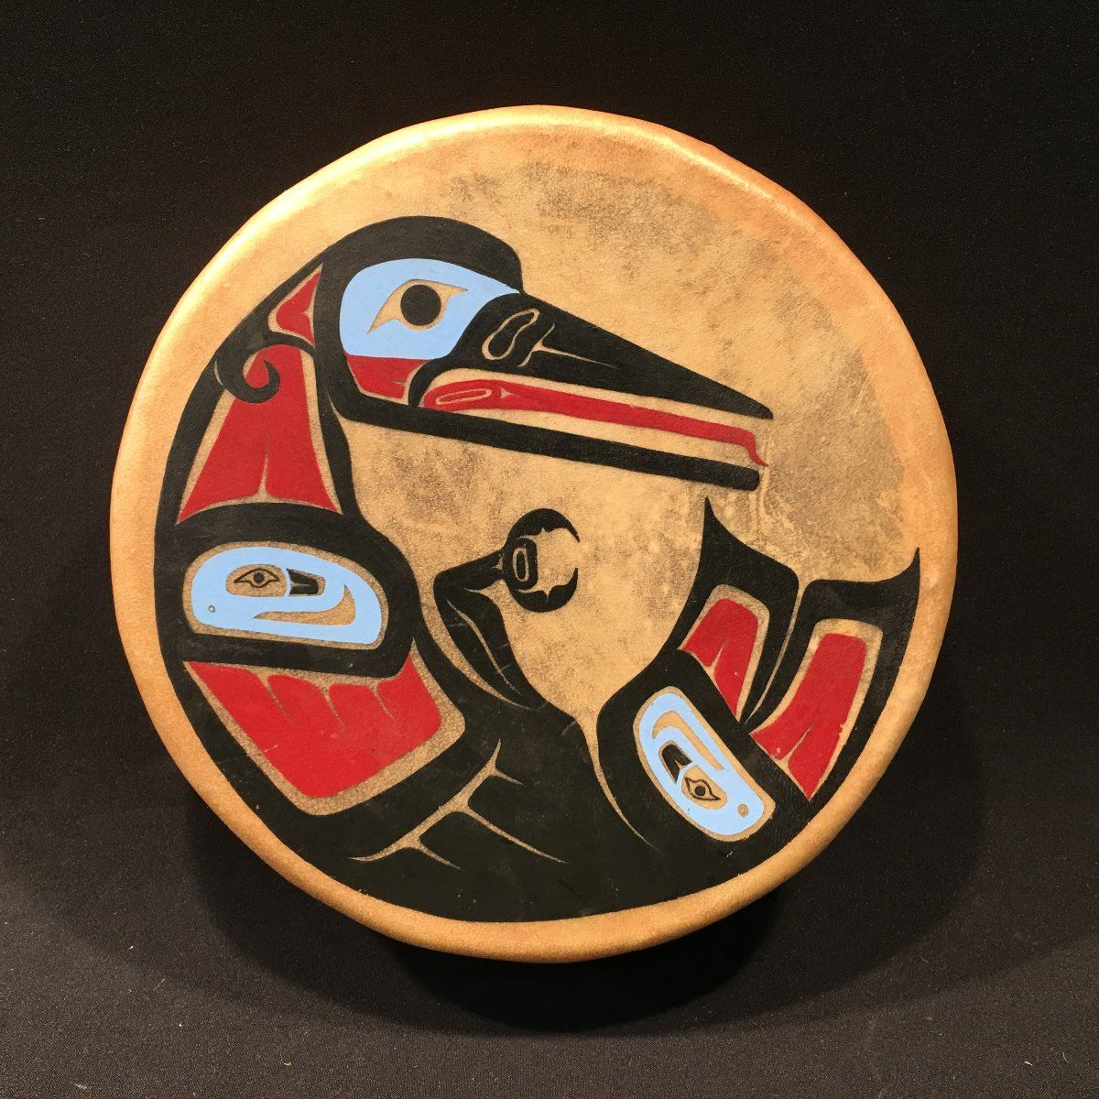 | Drum stick and finish drums  2:45-4: Group 1  4:45-6: Group 2 | Drum stick and finish drums  2:45-4: Group 3  4:45-6: Group 4
20 |  | 22
 | Halloween scavenger hunt and crafts  2:45-4: Group 1  4:45-6: Group 2 | Halloween scavenger hunt and crafts  2:45-4: Group 3  4:45-6: Group 4
27 |  | 29
Painted pumpkins  2:45-4: Group 1  4:45-6: Group 2 |  | Painted pumpkins  2:45-4: Group 3  4:45-6: Group 4
Youth groups will be held outside, weather permitting, or inside socially distanced. Each child may attend one group per week, pre-register for your time slot for the children from your household. New registration of times will happen each month.
*We ask all parents to stay outside when picking up and dropping off youth*

